Nama : Ratri Ika Sulfiani

NIM/Kelas : 23051204347/J

Prodi : Teknik Informatika

Matkul : Pemograman Dasar

**FLOWCHART**

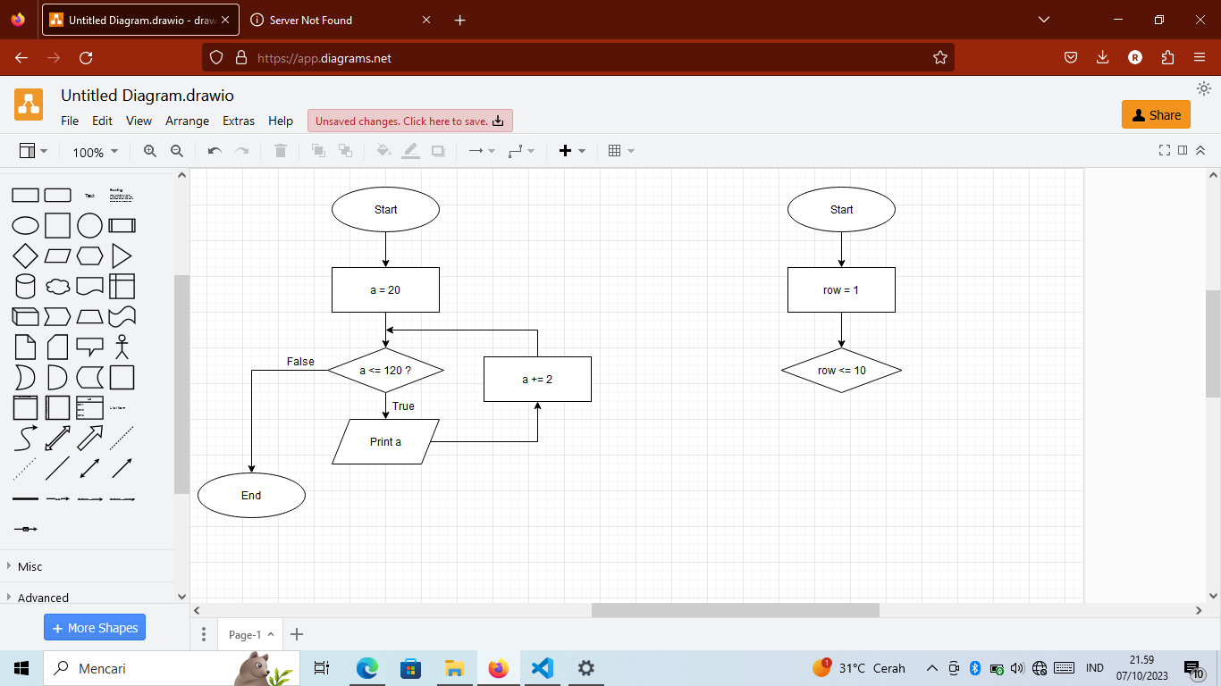

**PSEUDOCODE**

Start

For a in 20 to 120 do

a += 2

Print a

End for

End